# VELALAR COLLEGE OF ENGINEERING AND TECHNOLOGY (AUTONOMOUS)

**DEPARTMENT OF COMPUTER SCIENCE AND ENGINEERING REGULATION 2018 v4**

**21CSL52-WEB PROGRAMMING LABORATORY**



|  |  |  |
| --- | --- | --- |
| Ex:no:01 | **DESIGN A WEBPAGE USING HTML TO EMBED A MAP AND FIX THE HOTSPOTS** | Roll.no: |
| Date: | Page no: |

**AIM:**

To Create a web page with the following using HTML.

a. To embed a map in a web page.

b. To fix the hot spots in that map.

c. Show all the related information when the hot spots are clicked.

**ALGORITHM:**

STEP 1: Create a html file with map tag.

STEP 2: Set the source attribute of the img tag to the location of the image and also set the use map

attribute.

STEP 3: Specify an area with name, shape and href set of the appropriate value.

STEP 4: Repeat step3 as many hot spots you want to put in the map.

STEP 5: Create html file for each and every hot spots the user will select the particular location it shows information about it.

**PROGRAM:**

**Index.html**

<!DOCTYPE html>

<head>

<title>hotspots</title>

</head>

<body>

<img src="/indiamap.jpg" usemap="#map" width="600" height="700" >

<map name="map">

<area shape="rect" coords="80,307,180,204" href="RAJASTHAN.html">

<area shape="rect" coords="175,550,250,410" href="AP.html">

</map>

</html>

**Rajasthan.html**

<html>

<head>

<title>Rahasthan</title>

<style>

.slider {

background: url(rajasthan.png);

width: 500px;

height: 500px;

background-repeat: no-repeat;

background-size: 100%;

}

</style>

</head>

<body bgcolor="green">

<h1 style="color: white">RAJASTHAN</h1>

<div class="slider"></div>

<a href="index.html" style="color: pink">GO TO MAP</a>

<h4>

<p style="color: white">

Rajasthan is located on the northwestern side of India, where it

comprises most of the wide and inhospitable Thar Desert (also known as

the "Great Indian Desert") and shares a border with the Pakistani

provinces of Punjab to the northwest and Sindh to the west, along the

Sutlej-Indus river valley.

</p>

</h4>

</body>

</html>

**Ap.html**

<html>

<head>

<title>AP</title>

<style>

.slider {

background: url(ap.jpg);

width: 500px;

height: 500px;

background-repeat: no-repeat;

background-size: 100%;

}

</style>

</head>

<body bgcolor="lightgreen">

<h1>ANDHRA PRADESH</h1>

<div class="slider"></div>

<a href="index.html" style="color: red">GO TO MAP</a><br />

Andhra Pradesh hosted 121.8 million visitors in 2015, a 30% growth in

tourist arrivals over the previous year, making it the third most-visited

state in India.

</body>

</html>

**OUTPUT:**

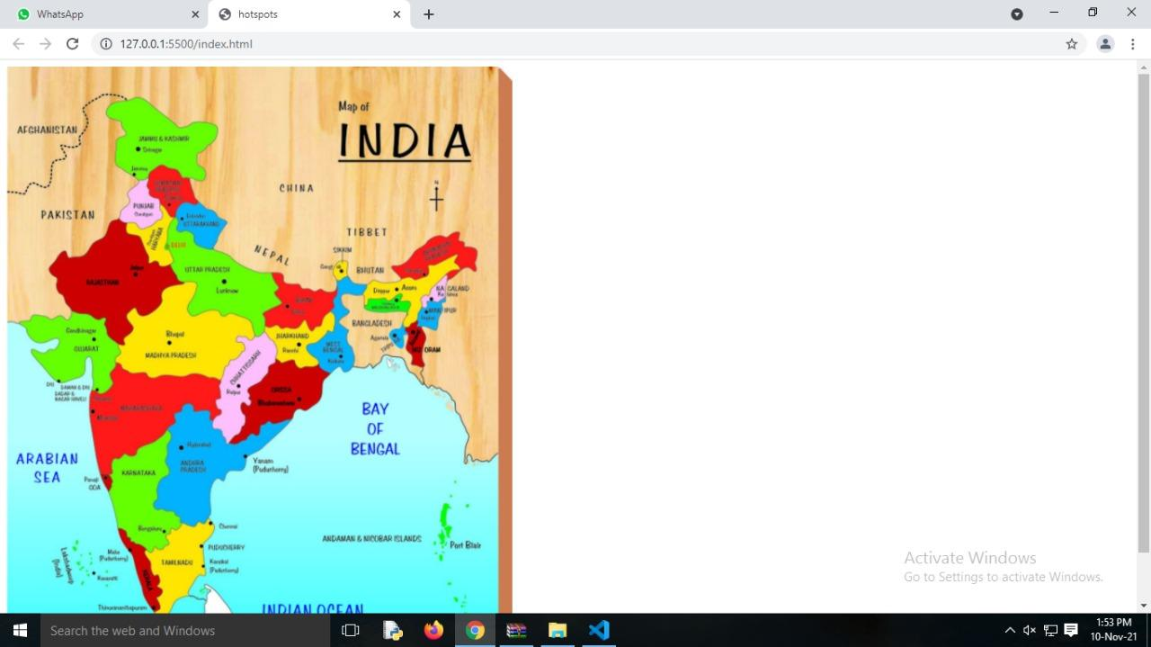

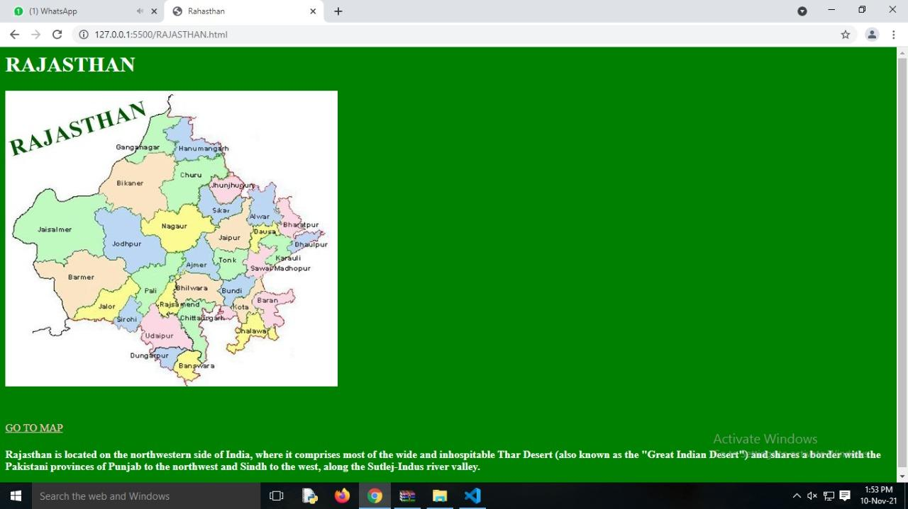

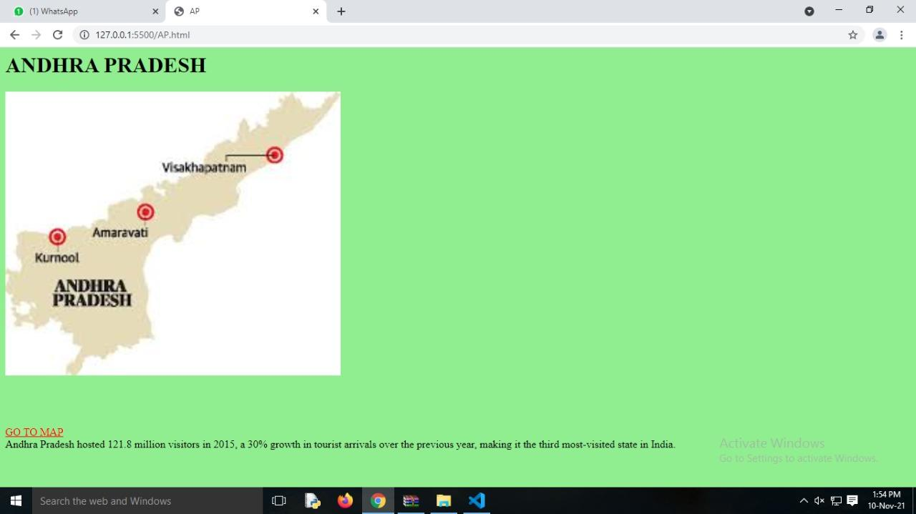

**RESULT:**

Thus the web page with hotspots has been executed and verified successfully.

|  |  |  |
| --- | --- | --- |
| Ex:no:2A | **CASCADING STYLE SHEETS** | Roll.no: |
| Date: | Page no: |

**AIM:**

To create a web page using cascading style sheets.

**ALGORITHM:**

Step1: Create html file with the style tag, inside head tag.

Step2: Set the style such as font-family, font-size, color, left etc, for the heading

h1,h2,…h6 and respectively.

Step3: Close the head tag.

Step4: Specify the heading and information required inside the body tag.

Step5: Close the opened tag.

**PROGRAM:**

**Index.html**

<html>

<head>

<title>External style sheet</title>

<link rel="stylesheet" href="style.css">

</head>

<body>

<div id="navbar">

<ul>

<li>HOME</li>

<li>SERVICES</li>

<li>ABOUT</li>

<li>CONTACT</li>

</ul>

</div>

<div id="container">

<img src="c.png">

<p>C programming is a general-purpose, procedural, imperative computer programming language developed in 1972 by Dennis M. Ritchie at the Bell Telephone Laboratories to develop the UNIX operating system. C is the most widely used computer language.

It keeps fluctuating at number one scale of popularity along with Java programming language, which is also equally popular and most widely used among modern software programmers.</p>

</div>

<h3>Want to learn more?<br><br><button>Click here!</button></h3>

</body>

</html>

**Style.css**

ul li {

float: left;

list-style-type: none;

}

li {

color: white;

font-weight: bold;

padding: 5px;

}

ul {

background-color: blue;

height: 30px;

width: 100%;

}

#container img {

float: right;

}

p {

text-align: center;

}

h3 {

margin: 10%;

}

button {

transition-duration: 0.4s;

text-align: center;

font-size: 20px;

}

button:hover {

background-color: blue;

color: white;

}

**OUTPUT:**

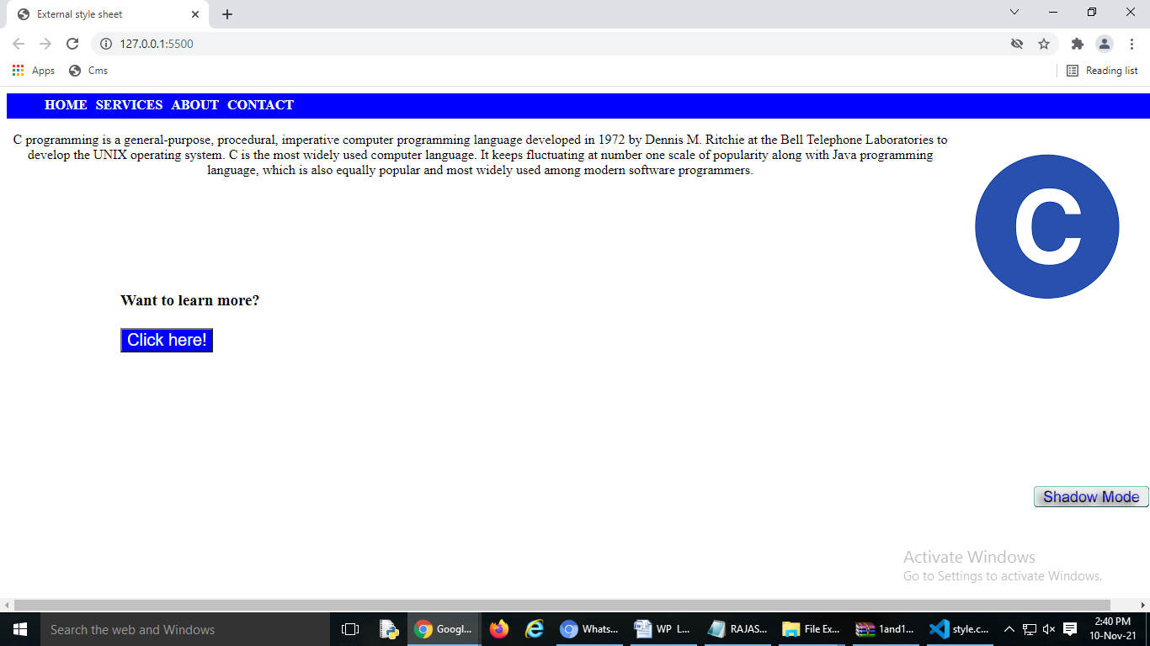

**RESULT:**

Thus a program that displays the cascading style sheets has been executed and verified successfully.

|  |  |  |
| --- | --- | --- |
| Ex:no:2B | **EMBEDDED STYLE SHEETS** | Roll.no: |
| Date: | Page no: |

**AIM:**

To create a web page using embedded style sheets.

**ALGORITHM:**

Step1: Create html file with the style tag, inside head tag.

Step2: Set the style such as font-family, font-size, color, left etc, for the heading

h, h2, …, h6 and respectively.

Step3: Close the head tag.

Step4: Specify the heading and information required inside the body tag.

Step5: Close the opened tag.

**PROGRAM:**

<!DOCTYPE html>

<html>

<head>

<meta charset="utf-8">

<meta name="viewport" content="width=device-width, initial-scale=1">

<title>Embedded style sheet </title>

</head>

<style>

ul li{

list-style-type: none;

float: left;

padding: 5px;

color: white;

font-weight: bold;

}

#navbar{

height: 30px;

width: 100%;

background-color: darkblue;

}

img{

height="300px";

width="300px";

border-radius: 2px;

border-width: 2px;

border-color: black;

margin: 10%;

}

p{

border-width: 2px;

border-color: black;

margin: 5%;

}

button {

transition-duration: 0.4s;

text-align: center;

font-size: 20px;

}

button:hover {

background-color: blue;

color: white;

}

</style>

<body>

<div id="navbar">

<ul><li>HOME</li>

<li>SERVICES</li>

<li>ABOUT</li>

<li>CONTACT</li></ul>

</div>

<div>

<img src="java.png" align="left">

<p>Java is among the most popular programming languages out there, mainly because of how versatile and compatible it is. Java can be used for a large number of things, including software development, mobile applications, and large systems development. As of 2019, 88% market share of all smartphones run on Android, the mobile operating system written in Java. Knowing Java opens a great deal of doors for you as a developer.</p></div>

<button>Click here</button>

</body>

</html>

**OUTPUT:**

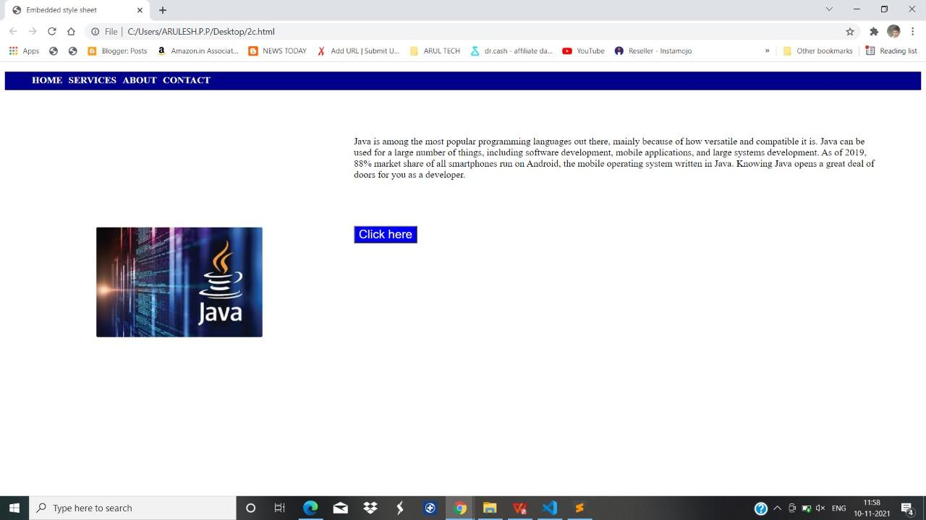

**RESULT:**

Thus a program that displays the embedded style sheets has been executed and verified successfully.

|  |  |  |
| --- | --- | --- |
| Ex:no:2C | **INLINE STYLE SHEETS** | Roll.no: |
| Date: | Page no: |

**AIM:**

To create a web page using Inline style sheets.

**ALGORITHM:**

Step1: Create html file with the style tag, inside head tag.

Step2: Set the style such as font-family, font-size, color, left etc, for the heading

h,h2,…, h6 and respectively.

Step3: Close the head tag.

Step4: Specify the heading and information required inside the body tag.

Step5: Close the opened tag.

**PROGRAM:**

<!DOCTYPE html>

<html>

<head>

<meta charset="utf-8">

<meta name="viewport" content="width=device-width, initial-scale=1">

<title>Inline style sheets:</title>

</head>

<body style="margin-left: 5px;">

<div>

<ul style="background-color:darkblue;width: 100%;height: 35px;">

<li style="float: left;list-style-type: none;padding: 5px;color: white;font-weight: bold;">HOME</li>

<li style="float: left;list-style-type: none;padding: 5px;color: white;font-weight: bold;">SERVICES</li>

<li style="float: left;list-style-type: none;padding: 5px;color: white;font-weight: bold;">COURSES</li>

<li style="float: left;list-style-type: none;padding: 5px;color: white;font-weight: bold;">ABOUT</li>

<li style="float: left;list-style-type: none;padding: 5px;color: white;font-weight: bold;">CONTACT</li>

</ul>

</div>

<h1 style="color: blue;font-family: verdana;font-size: 300%;">PYTHON</h1>

<img src="py.png" style="border: 1px solid #ddd;border-radius: 4px;padding: 5px; display: block;margin-left: auto;margin-right: auto;width: 500px;">

<p style="color: #111111;font-family: courier;font-size: 160%;overflow: hidden;">It ranges from simple automation tasks to gaming, web development, and even complex enterprise systems. These are the areas where this technology is still the king with no or little competence: Machine learning as it has a plethora of libraries implementing machine learning algorithms.</p>

</body>

</html>

**OUTPUT:**



**RESULT:**

Thus a program displays the inline style sheet that has been executed and verified successfully.

|  |  |  |
| --- | --- | --- |
| Ex:no:03 | **VALIDATING REGISTRATION FORM USING JAVASCRIPT** | Roll.no: |
| Date: | Page no: |

**AIM:**

To create a registration form and validate them using JavaScript functions.

**ALGORITHM:**

Step 1: Start the program.

Step 2: Create a Registration form contains the fields like name, Password ,E-mail id ,Phone number, Date of birth , Languages known and Address.

Step 3: Create a JavaScript file to validate the registration form.

Step 4: Validation is done for username , password , E-Mail id and Phone Number.

Step 5: Stop the program.

**PROGRAM:**

**form.html**

<html>

<head>

<title>Registration Form</title>

</head>

<body>

<h1 align="center">Registration Form</h1>

<form id="form1">

<label>First name: </label>

<input type="text" name="firstname" required>

<br /><br />

<label>Last name: </label>

<input type="text" name="lastname">

<br /><br />

<label>Username: </label>

<input type="text" id="username" required/>

<br /><br />

<span>*Enter alphabets only.</span>

<br /><br />

<label>Enter your Password:</label>

<input type="password" id="pwd">

<br /><br />

<span>*Enter atleast 8 characters</span>

<br /><br />

<label>Re-enter Password:</label>

<input type="password" id="re_pwd">

<br /><br />

<label>Gender:</label>

<input type="radio" name="rad" checked="checked">Male

<input type="radio" name="rad">Female

<br /><br />

<label>Birthday:</label>

<input type="date" name="bday">

<br /><br />

<label>Email:</label>

<input type="email" id="email"/>

<br /><br />

<label>Mobile.No:</label>

<input type="text" id="mn"/>

<br /><br />

<label>Upload your Photo: </label>

<input type="file" name="myFile">

<br /><br />

<input type="button" value="Submit" onclick="validateForm()"/>

<input type="reset">

</form>

<script src="test.js"></script>

</body>

</html>

**test.js**

function validateForm() {

// validate username

var username = document.getElementById("username");

var alphabetsOnly = /^[a-z A-Z]+$/g;

if (!alphabetsOnly.test(username.value)) {

alert("Only alphabets are allowed for username");

return;

}

if (username.length< 15) {

alert('username should at least contain 15 characters');

return;

}

// validate password

var mypwd = document.getElementById("pwd");

var myrepwd = document.getElementById("re_pwd");

if(mypwd.value.length< 8) {

alert("Password should contain at least 8 characters");

mypwd.focus();

return;

} else if(mypwd.value != myrepwd.value) {

alert("Passwords are not matching");

mypwd.focus();

return;

}

// validate mobile number

var ph = document.getElementById("mn");

var numbersOnly = /^[0-9]{10}$/g;

if (!numbersOnly.test(ph.value)) {

alert('Mobile number should contain exactly 10 numbers');

return;

}

// validate email

if(!(/^\w+([\.-]?\w+)*@\w+([\.-]?\w+)*(\.\w{2,3})+$/.test(form1.email.value))) {

alert("Invalid email id");

return;

}

}

**OUTPUT:**

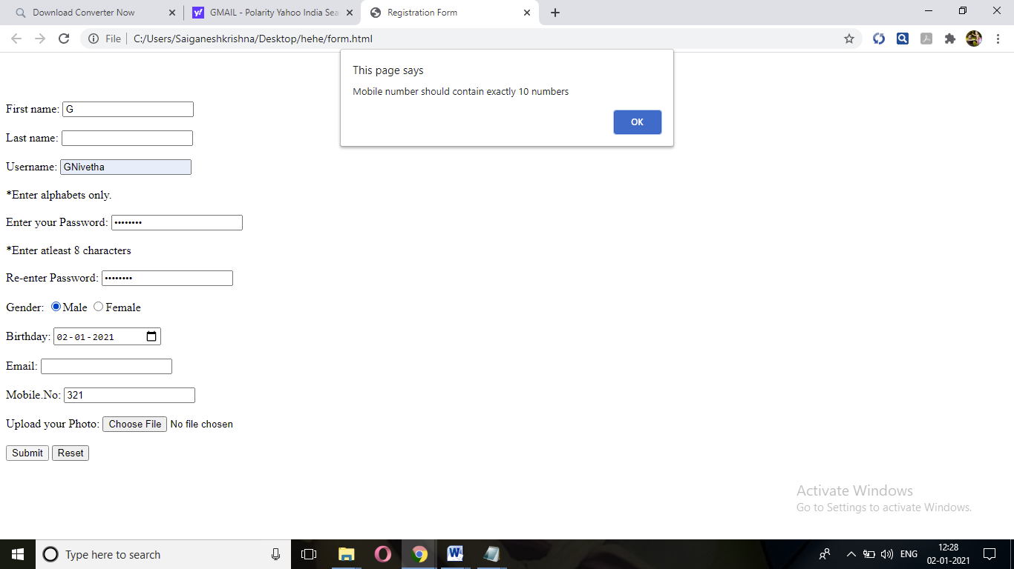

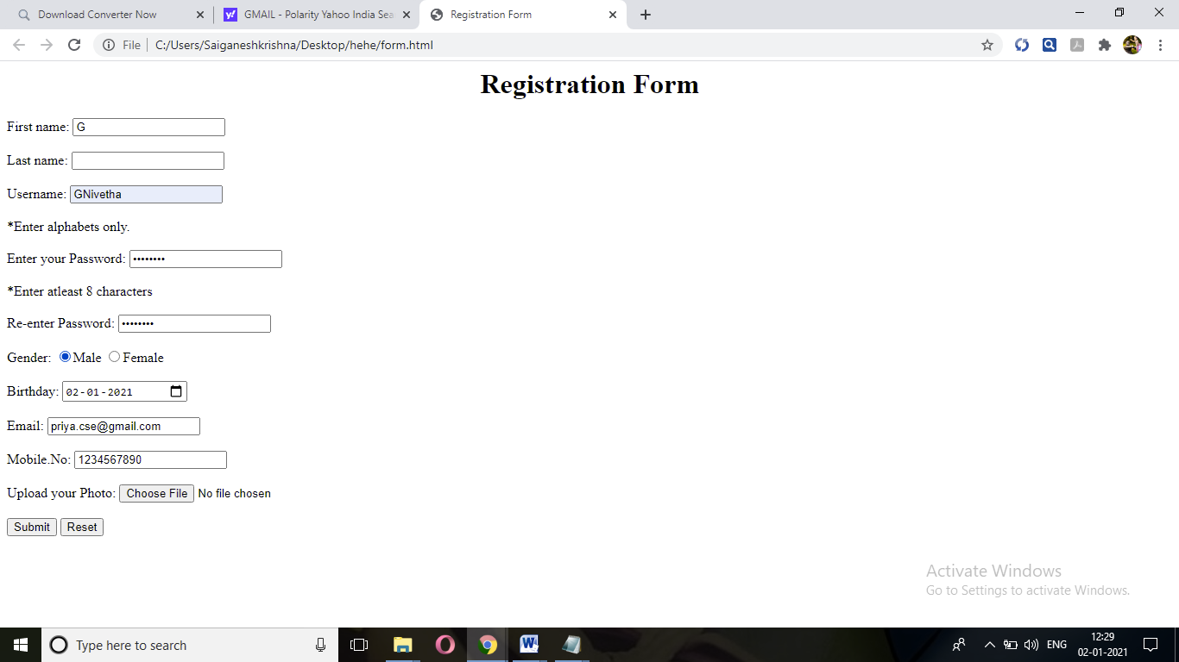

**RESULT:**

Thus the registration form has been executed and verified successfully.

|  |  |  |
| --- | --- | --- |
| Ex:no:04 | **IMPLEMENTATION OF JAVASCRIPT TO CONVERT**  **NUMERICAL VALUES TO WORDS** | Roll.no: |
| Date: | Page no: |

**AIM:**

To write a HTML page including required JavaScript that takes a number from one text field and display it in another field.

**ALGORITHM:**

Step 1: Start the program.

Step 2: Create a HTML Page to get a number from the user in the range of 0 to 999.

Step 3: Create a JavaScript function to convert number to words.

Step 4: If the number is out of range then it displays that “The number is out of range “.

Step 5: If the value is not a number then it displays “ Not a number “.

Step 6: Display the number entered as words if the above condition get fails.

Step 7: Stop the program.

**PROGRAM:**

<html>

<head>

<title>EX 4</title>

</head>

<body style="background-color:mediumseagreen; color:dongerblue">

<script language="javascript">

function numtowords(number)

{

hyphen = '-';

conjunction = ' and ';

separator = ', ';

dictionary = {

0 : 'zero',

1 : 'one',

2 : 'two',

3 : 'three',

4 : 'four',

5 : 'five',

6 : 'six',

7 : 'seven',

8 : 'eight',

9 : 'nine',

10 : 'ten',

11 : 'eleven',

12 : 'twelve',

13 : 'thirteen',

14 : 'fourteen',

15 : 'fifteen',

16 : 'sixteen',

17 : 'seventeen',

18 : 'eighteen',

19 : 'nineteen',

20 : 'twenty',

30 : 'thirty',

40 : 'fourty',

50 : 'fifty',

60 : 'sixty',

70 : 'seventy',

80 : 'eighty',

90 : 'ninety',

100 : 'hundred',

};

if (number < 0 || number > 999)

{

alert("Enter a number range between 0 and 999");

return "";

}

switch (true)

{

case (number < 21):

string = dictionary[number];

break;

case (number < 100):

tens = parseInt(number / 10) * 10;

units = number % 10;

string = dictionary[tens];

if (units)

{

string += hyphen + dictionary[units];

}

break;

case (number < 1000):

hundreds = parseInt(number / 100);

remainder = number % 100;

string = dictionary[hundreds] + ' ' + dictionary[100];

if (remainder)

{

string += conjunction + numtowords(remainder);

}

break;

default:

break;

}

return string;

}

a=prompt("Enter a number");

num=parseInt(a);

document.write(numtowords(num));

</script>

</body>

</html>

**OUTPUT:**

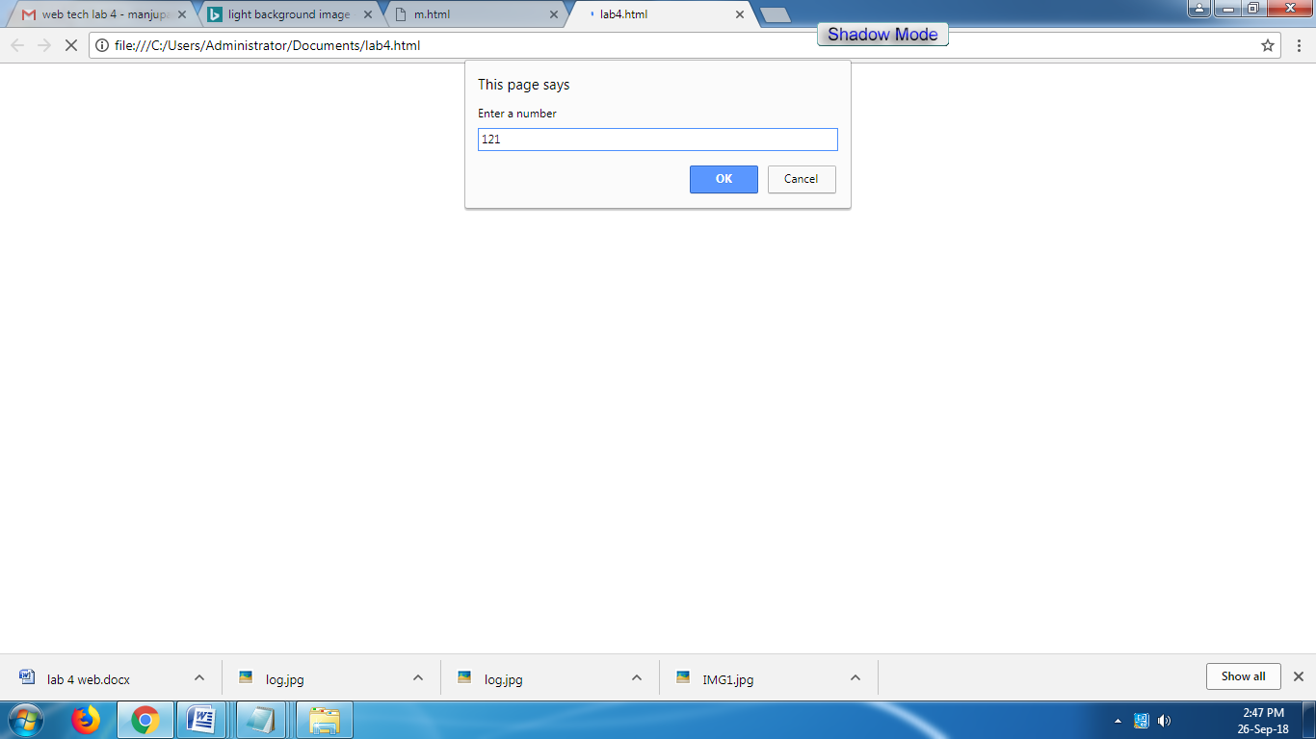

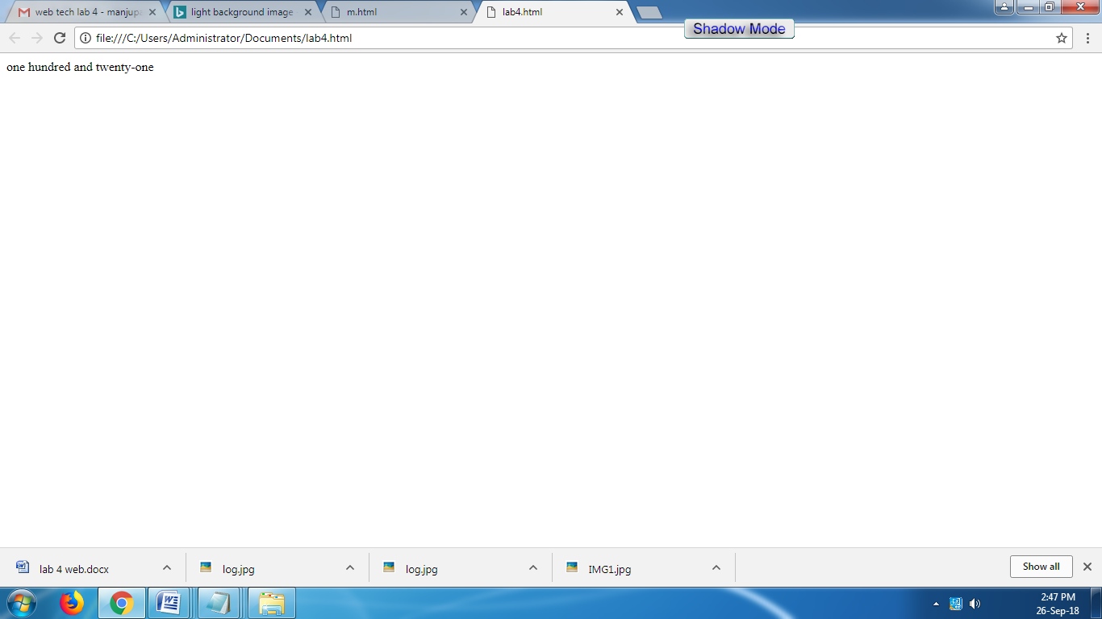

**RESULT:**

Thus a Html page including required javascript that takes a number from one text field and display it in another field has been executed and verified successfully.

|  |  |  |
| --- | --- | --- |
| Ex:no:05 | **DESIGN A ORDER FORM USING ANGULAR JS** | Roll.no: |
| Date: | Page no: |

**AIM:**

To Write an Angular JS framework that allows users to design a order form with a total price updated in real time.

**ALGORITHM:**

Step 1: Start the program.

Step 2: Create a java Script function having a dictionary of product name and price.

Step 3: Create a html file having ADD and REMOVE button.

Step 4: In this file give the functions of ADD and REMOVE buttons.

Step 5: Calculate the total price in html file.

Step 6: Load the main page to see the output.

Step 7: Stop the program.

**PROGRAM:**

<!DOCTYPE html>

<html>

<script src="https://ajax.googleapis.com/ajax/libs/angularjs/1.6.9/angular.min.js"></script>

<body>

<style>

table {

border-collapse: collapse;

}

th, td {

padding: 10px;

text-align: left;

}

</style>

<div ng-app="myApp" ng-controller="myCtrl">

<table border="1">

<tr>

<th>Name</th>

<th>Quantity</th>

<th>Price Per Item</th>

<th>Total Price</th>

<th>Add Item</th>

<th>Remove Item</th>

</tr>

<tr ng-repeat="product in products">

<td>{{product.name}}</td>

<td>{{product.quantity}}</td>

</td>

<td>Rs.{{product.price}}</td>

<td>Rs.{{product.quantity*product.price}}</td>

<td><button class="btnbtn-primary" ng-click="add(product)">ADD</button></td>

<td><button class="btnbtn-danger" ng-click="remove(product)">REMOVE</button></td>

</tr>

</table>

<h2>Total Price: {{totalPrice}}</h2>

</div>

<script>

var app = angular.module('myApp', []);

app.controller('myCtrl', function ($scope) {

$scope.products = [

{

name: "Miranda",

quantity: 0,

price: 100

},

{

name: "Pepsi",

quantity: 0,

price: 75

},

{

name: "Fanta",

quantity: 0,

price: 85

},

{

name: "Fizz",

quantity: 0,

price: 80

},

]

$scope.totalPrice = 0

$scope.add = (product) => {

if(product.quantity >= 0){

product.quantity++;

$scope.totalPrice = $scope.totalPrice + product.price

}

}

$scope.remove = (product) => {

if(product.quantity > 0){

product.quantity--;

$scope.totalPrice = $scope.totalPrice - product.price

}

}

});

</script>

</body>

</html>

**OUTPUT:**

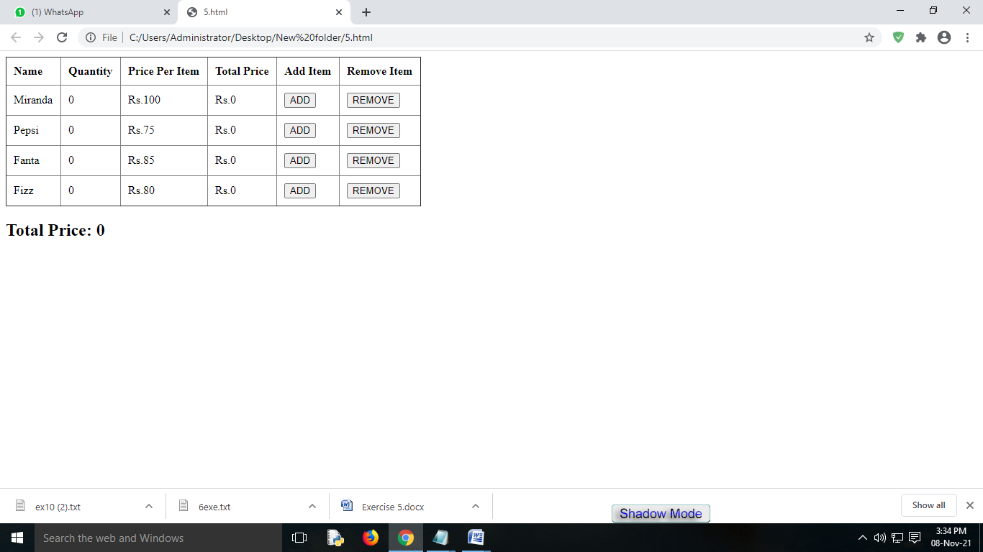

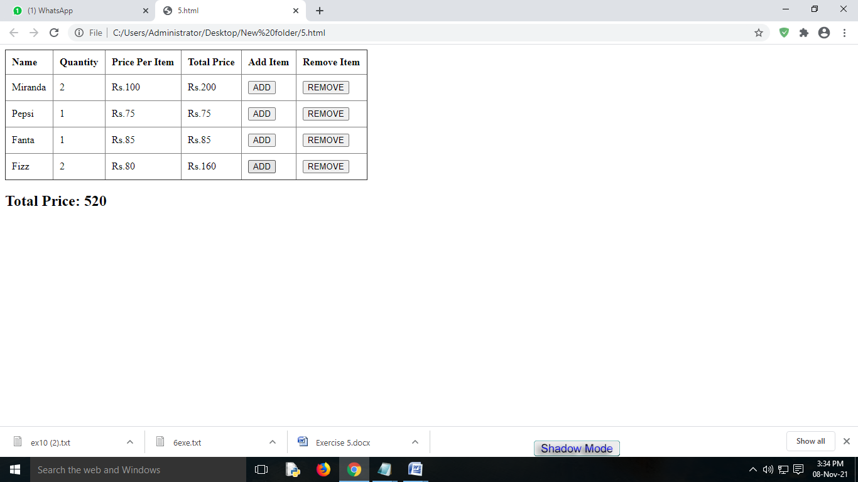

**RESULT:**

Thus the program to update the total price in real time has been executed and verified successfully.

|  |  |  |
| --- | --- | --- |
| Ex:no:06 | **DESIGN DIFFERENT LAYOUT MODES (GRID OR LIST) USING ANGULAR JS** | Roll.no: |
| Date: | Page no: |

**AIM:**

To create an Angular JS framework that allows users to switching between different layout modes (grid or list) with a click of a button.

**ALGORITHM:**

Step 1: Start the program.

Step 2: Create a html file which contains students details.

Step 3: In this html file create a button to change the layout when the button is clicked.

Step 4: Create a java script function and set if the switch is in grid then change the layout to grid otherwise in list.

Step 5: Load the main page and click the button to change the layout.

Step 6: Stop he program.

**PROGRAM:**

**HTML FILE**

<html xmlns="http://www.w3.org/1999/xhtml">

<head>

<title></title>

<style type="text/css">

.bar

{

background-color: #5c9bb7;

background-image: -webkit-linear-gradient(top, #5c9bb7, #5392ad);

background-image: -moz-linear-gradient(top, #5c9bb7, #5392ad);

background-image: linear-gradient(top, #5c9bb7, #5392ad);

box-shadow: 0 1px 1px #ccc;

border-radius: 2px;

width: 580px;

padding: 10px;

margin: 45px auto 25px;

position: relative;

text-align: right;

line-height: 1;

}

.bar a

{

background: #4987a1 center center no-repeat;

width: 32px;

height: 32px;

display: inline-block;

text-decoration: none !important;

margin-right: 5px;

border-radius: 2px;

cursor: pointer;

}

.bar a.active

{

background-color: #c14694;

}

/*------List layout------*/

ul.list

{

list-style: none;

width: 500px;

margin: 0 auto;

text-align: left;

}

ul.list li

{

padding: 10px;

overflow: hidden;

}

ul.list li img

{

float: left;

border: none;

}

ul.list li p

{

margin-left: 135px;

font-weight: bold;

color: black;

}

/*------Grid layout------*/

ul.grid

{

list-style: none;

width: 570px;

margin: 0 auto;

text-align: left;

}

ul.grid li

{

padding: 10px;

float: left;

color: black;

font-weight: bold;

}

</style>

<script type="text/javascript" src="https://cdnjs.cloudflare.com/ajax/libs/angular.js/1.7.8/angular.min.js"></script>

<script type="text/javascript">

var app = angular.module("MyApp", []);

app.controller("MyController", function ($scope) {

$scope.layout = 'grid';

$scope.Data = [

{ Name: "Desert" },

{ Name: "Hydrangeas" },

{ Name: "Jellyfish" },

{ Name: "Koala" },

{ Name: "Lighthouse" },

{ Name: "Penguins" },

{ Name: "Tulips"}];

});

</script>

</head>

<body>

<div ng-app="MyApp" ng-controller="MyController">

<div class="bar">

<a class="list-icon" ng-class="{active: layout == 'list'}" ng-click="layout = 'list'">

</a><a class="grid-icon" ng-class="{active: layout == 'grid'}" ng-click="layout = 'grid'">

</a>

</div>

<ul ng-show="layout == 'grid'" class="grid">

<li ng-repeat="data in Data"><p>{{data.Name}}</p></li>

</ul>

<ul ng-show="layout == 'list'" class="list">

<li ng-repeat="data in Data">

<p>{{data.Name}}</p>

</li>

</ul>

</div>

</body>

</html>

**OUTPUT:**

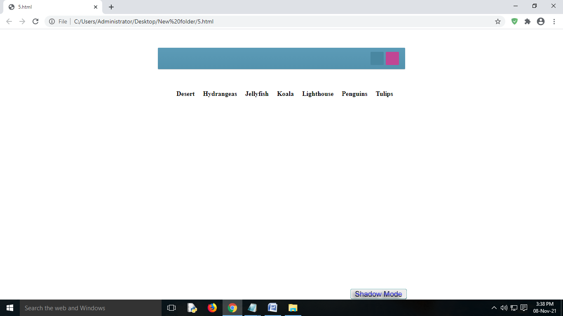

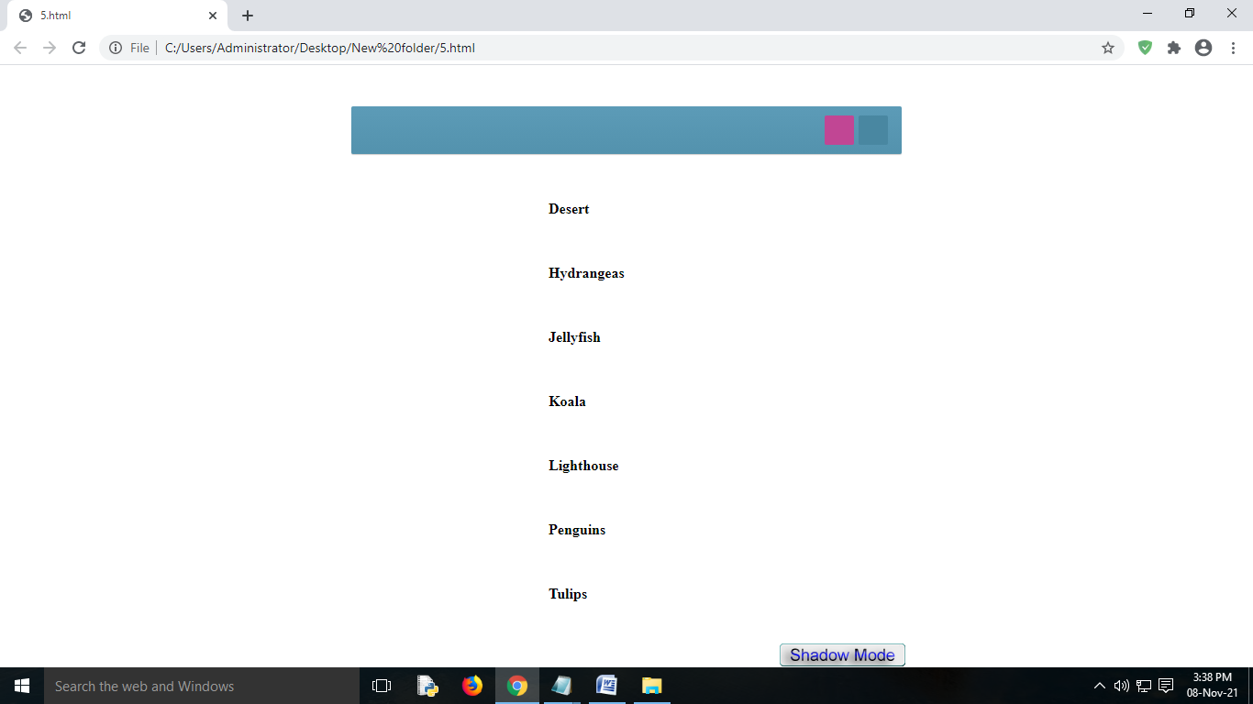

**RESULT:**

Thus the program to toggle between grid and list layout has been executed and verified successfully.

|  |  |  |
| --- | --- | --- |
| Ex:no:07 | **DESIGN A WEBPAGE THAT DISPLAYS USER INFORMATION USING XML** | Roll.no: |
| Date: | Page no: |

**AIM:**

To Create and save an XML document at the server, which contains 10 users Information. And write a Program, which takes user Id as an input and returns the User details by taking the user information from the XML document.

**ALGORITHM:**

step 1: Start the program.

Step 2: Create an XML file having 10 user information.

Step 3: Write an HTML program that takes user id as input and submit button.

Step 4: Write a function that fetches the server and read the data of the user from the xml file and should return the data.

Step 5: Display the details of the user.

Step 6: Else display invalid.

Step 7: Stop the program.

**PROGRAM:**

**Data.xml**

<?xml version="1.0" encoding="UTF-8"?>

<userlist>

<user>

<userid>usr01</userid>

<username>Gouse</username>

<address>DSNR</address>

<phone>8801550101</phone>

<email>Gouse.sheikh@gmail.com</email>

</user>

<user>

<userid>usr02</userid>

<username>D Divakar</username>

<address>Ameerpet</address>

<phone>9888888888</phone>

<email>D Divakar@gmail.com</email>

</user>

<user>

<userid>usr03</userid>

<username>Rajinth</username>

<address>SR Nagar</address>

<phone>9866666666</phone>

<email>Rajinth@yahoo.com</email>

</user>

</userlist>

**Index.html**

<!DOCTYPE html>

<html lang="en">

<head>

<meta charset="UTF-8">

<meta http-equiv="X-UA-Compatible" content="IE=edge">

<meta name="viewport" content="width=device-width, initial-scale=1.0">

<link rel="stylesheet" href="/styles.css">

<title>Document</title>

</head>

<body>

<div class="container">

<h2>User Details</h2>

<input type="text" id="uname" placeholder="Enter User Id"><br><br>

<button id="btn" onclick="okie()">Submit</button>

</div>

<br>

<div>

<h3 id="result"></h3>

</div>

</body>

<script src="/script.js"></script>

</html>

**Script.js**

function okie() {

let id = document.getElementById("uname").value;

let flag = 0;

console.log("hi")

let url = "data.xml";

fetch(url)

.then((response) => response.text())

.then((data) => {

let parser = new DOMParser();

let xml = parser.parseFromString(data, "application/xml");

let userid = xml.getElementsByTagName("userid");

let username = xml.getElementsByTagName("username");

let address = xml.getElementsByTagName("address");

let phone = xml.getElementsByTagName("phone");

let email = xml.getElementsByTagName("email");

for (let i = 0; i < userid.length; i++) {

if (id == userid[i].firstChild.nodeValue) {

let user =

username[i].firstChild.nodeValue +

" - " +

address[i].firstChild.nodeValue +

" - " +

phone[i].firstChild.nodeValue +

" - " +

email[i].firstChild.nodeValue;

document.getElementById("result").innerHTML = user;

flag = 1;

}

}

if (flag === 0) {

document.getElementById("result").innerHTML = "Invalid User";

}

});

}

okie()

**styles.css:**

.container {

position: relative;

top: 10%;

left: 40%;

}

#btn {

margin-left: 65px;

padding: 10px;

padding-left: 25px;

padding-right: 25px;

font-size: small;

border: 1px solid black;

background-color: black;

color: white;

transition: 0.2s;

}

#btn:hover {

background-color: white;

border: 1px solid black;

color: black;

}

h2 {

margin-left: 45px;

}

input {

padding: 25px;

padding-left: 35px;

padding-right: 35px;

border: 0px;

box-shadow: 0px 0px 10px 8px rgb(238, 238, 238);

}

input:focus {

background-color: white;

outline: none;

}

#result {

margin-left: 30%;

margin-top: 80px;

}

**OUTPUT:**

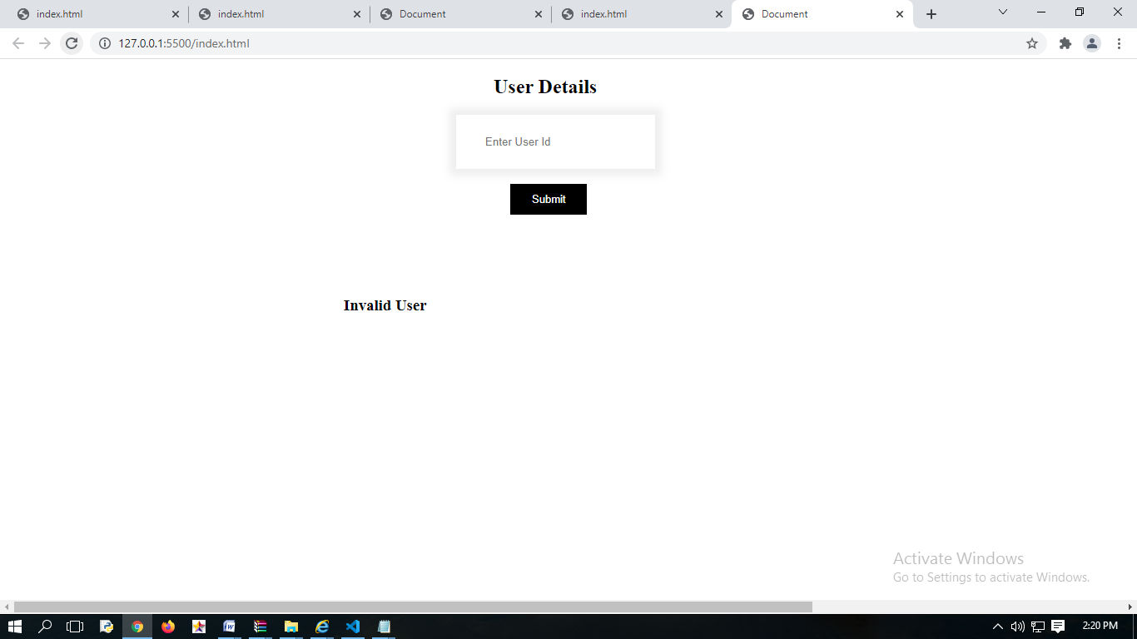

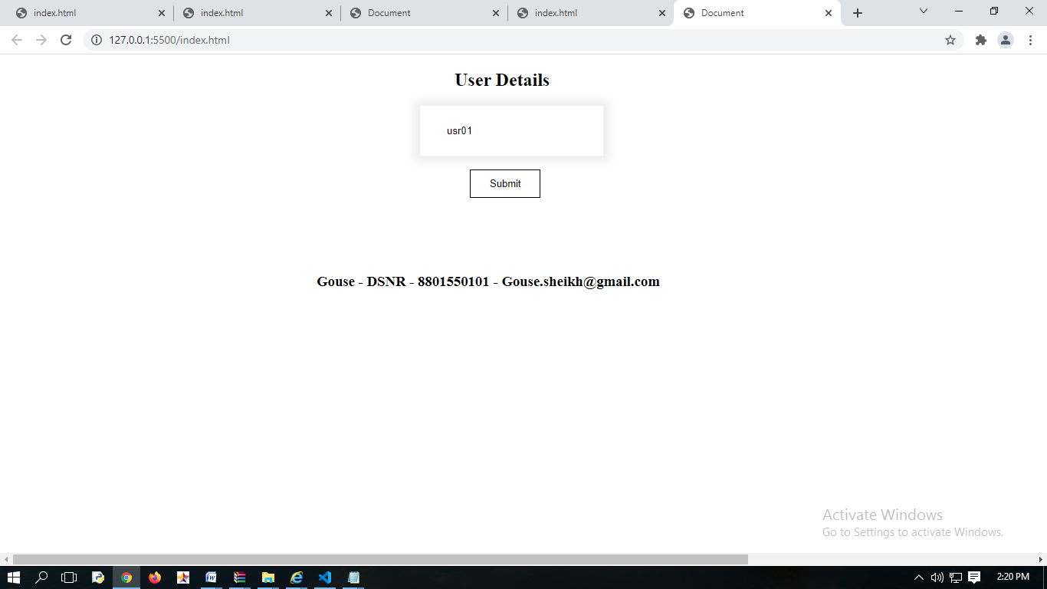

**RESULT:**

Thus the program to read the data of user from the xml file has been successfully implemented using html.

|  |  |  |
| --- | --- | --- |
| Ex:no:08 | **CREATE CONTACTS ADDRESS BOOK USING XML AND VALIDATE WITH DTD** | Roll.no: |
| Date: | Page no: |

**AIM:**

To Write a DTD for an XML document that declares an address book containing contacts.

**ALGORITHM:**

Step 1: Start the program

Step 2: Create an XML document which declares address book of the contacts.

Step 3: Write a DTD for an XML file.

Step 4: Load the main page to get the output

Step 5: Stop the program.

**PROGRAM:**

<?xml version="1.0" encoding="utf-8"?>

<!DOCTYPE AddressBook [

<!ELEMENT AddressBook (Address+)>

<!ELEMENT Address (Name, Street, City,phoneno)>

<!ATTLIST Address id CDATA #REQUIRED>

<!ELEMENT Name (#PCDATA)>

<!ELEMENT Street (#PCDATA)>

<!ELEMENT City (#PCDATA)>

<!ELEMENT phoneno (#PCDATA)>

]>

<AddressBook >

<Address id='1'>

<Name >Jeniffer</Name>

<Street >Wall Street </Street >

<City> New York </City >

<phoneno>91 21898912</phoneno>

</Address >

<Address id='2'>

<Name >Udaya</Name >

<Street>Ram Nager</Street >

<City> New York </City >

<phoneno>91 21898912</phoneno>

</Address >

<Address id='3'>

<Name >Tharun</Name >

<Street> Shivanagar </Street >

<City> New York </City >

<phoneno>91 21898912</phoneno>

</Address >

</AddressBook >

**OUTPUT:**

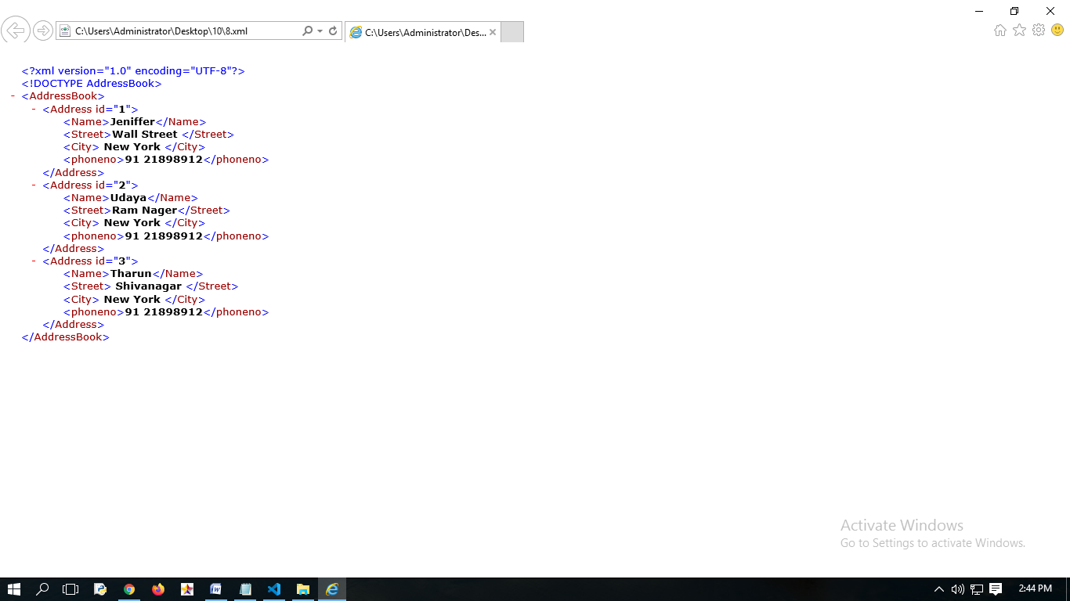

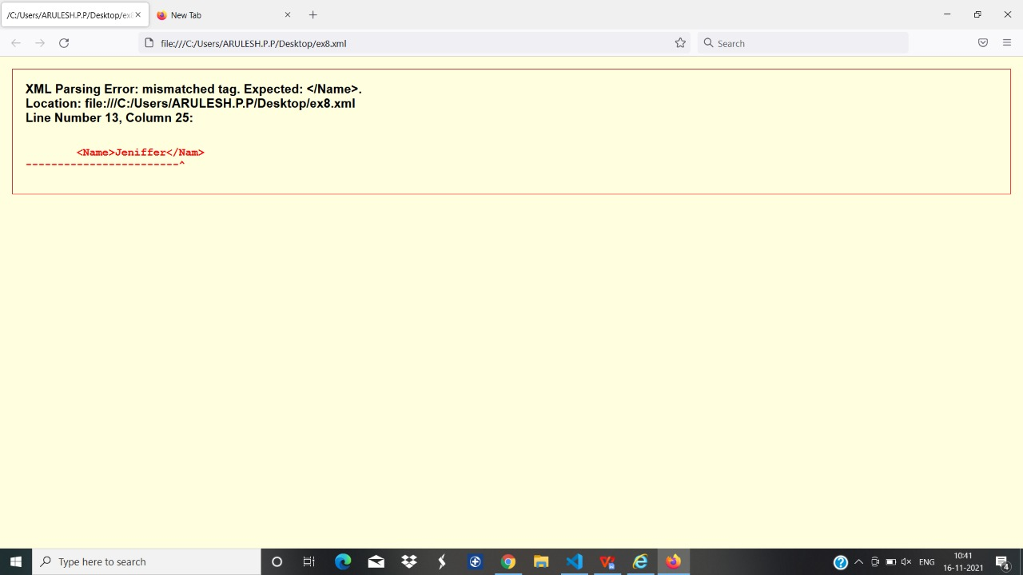

**RESULT:**

Thus the program to valid an XML file using DTD has been executed and verified successfully.

|  |  |  |
| --- | --- | --- |
| Ex:no:09 | **IMPLEMENTATION OF AJAX** | Roll.no: |
| Date: | Page no: |

**AIM**:

To write a program that displays the Customer details.

**ALGORITHM**:

Step 1: Start the program

Step 2: Create a html file that gets the request from the user .

Step 3: Write the JavaScript code that gets content and displays the profile of the customer.

Step 4: Create a submit button using html tags

Step 5: Create an XML file containing customer details and include it in the html document

Step 6: Load the main page to get the output

Step 7: Stop the program

**PROGRAM:**

<!DOCTYPE html PUBLIC "-//W3C//DTD XHTML 1.0 Transitional//EN""http://www.w3.org/TR/xhtml1/DTD/xhtml1-transitional.dtd">

<html xmlns="http://www.w3.org/1999/xhtml">

<head>

<title></title>

<style type="text/css">

body {

font-family: Arial;

font-size: 10pt;

}

table {

border: 1px solid #ccc;

border-collapse: collapse;

}

table th {

background-color: #F7F7F7;

color: #333;

font-weight: bold;

}

table th,

table td {

padding: 5px;

border-color: #ccc;

}

</style>

</head>

<body>

<h1>AJAX Programming</h1>

<input type="button" id="btnGenerate" value="Enter" />

<hr />

<div id="dvTable">

</div>

<script type="text/javascript" src="http://ajax.googleapis.com/ajax/libs/jquery/1.8.3/jquery.min.js"></script>

<script type="text/javascript">

$(function() {

$("#btnGenerate").click(function() {

//Build an XML containing Customer records.

var xml = "<Customers>";

xml += "<Customer>";

xml += "<CustomerId>1</CustomerId><Name>John Hammond</Name><Country>United States</Country>";

xml += "</Customer>";

xml += "<Customer>";

xml += "<CustomerId>2</CustomerId><Name>Mudassar Khan</Name><Country>India</Country>";

xml += "</Customer>"

xml += "<Customer>";

xml += "<CustomerId>3</CustomerId><Name>Suzanne Mathews</Name><Country>France</Country>";

xml += "</Customer>";

xml += "<Customer>";

xml += "<CustomerId>4</CustomerId><Name>Robert Schidner</Name><Country>Russia</Country>";

xml += "</Customer>";

xml += "</Customers>";

var xmlDoc = $.parseXML(xml);

var customers = $(xmlDoc).find("Customer");

//Create a HTML Table element.

var table = $("<table />");

table[0].border = "1";

//Add the header row.

var row = $(table[0].insertRow(-1));

customers.eq(0).children().each(function() {

var headerCell = $("<th />");

headerCell.html(this.nodeName);

row.append(headerCell);

});

//Add the data rows.

$(customers).each(function() {

row = $(table[0].insertRow(-1));

$(this).children().each(function() {

var cell = $("<td />");

cell.html($(this).text());

row.append(cell);

});

});

var dvTable = $("#dvTable");

dvTable.html("");

dvTable.append(table);

});

});

</script>

</body>

</html>

**OUTPUT:**

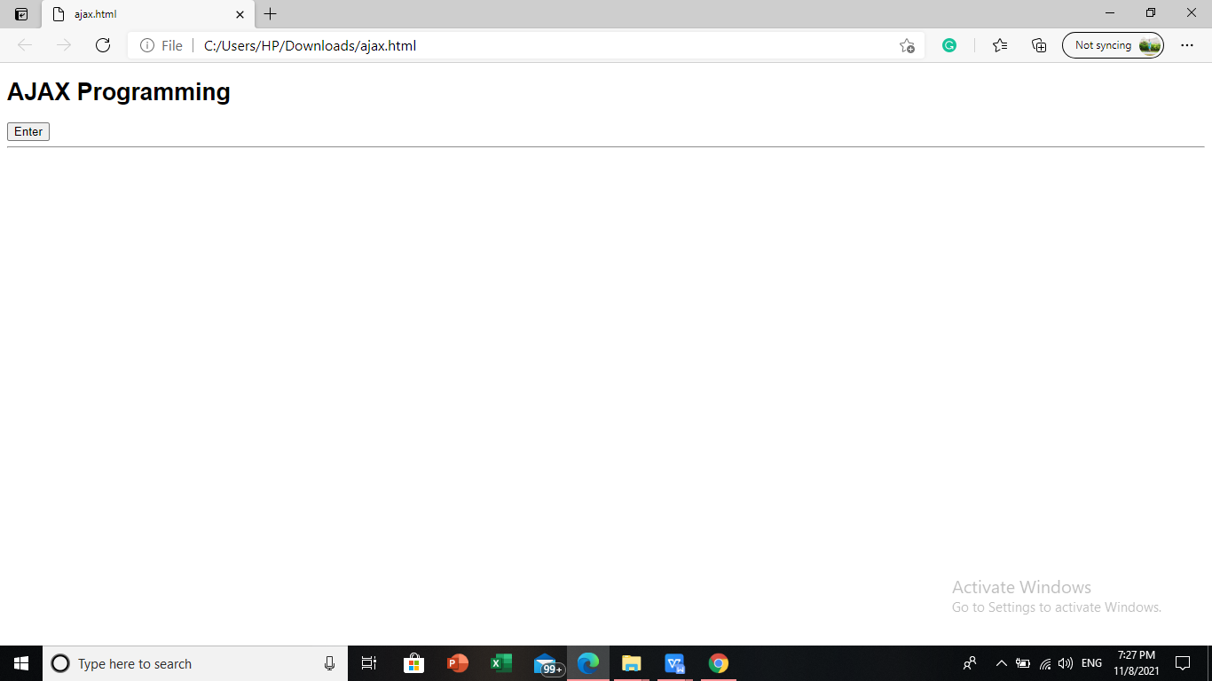

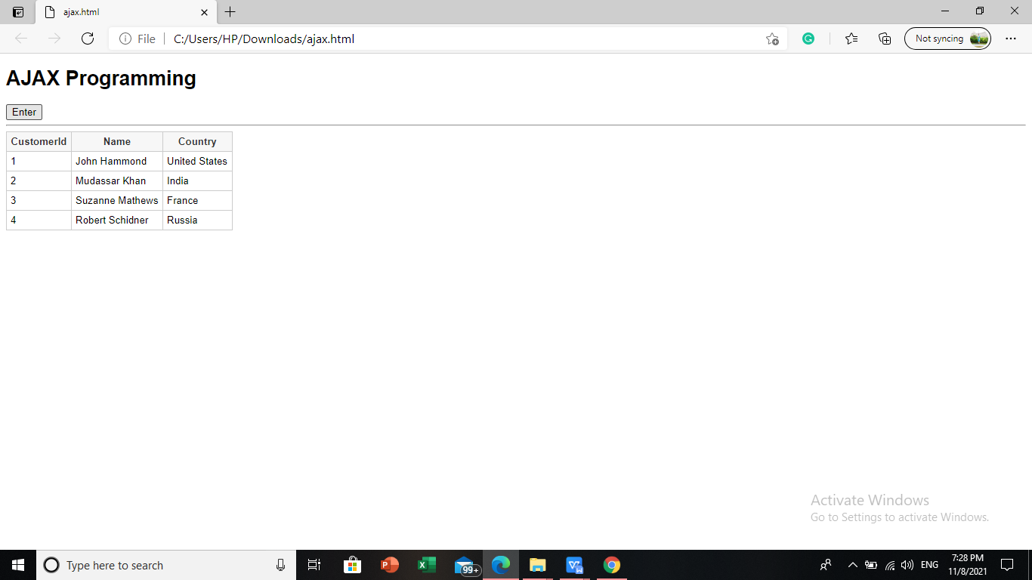

**RESULT:**

Thus a program that displays customer details has been executed and verified successfully.

|  |  |  |
| --- | --- | --- |
| Ex:no:10 | **IMPLEMENTING AN APPLICATION WITH WEB SERVICES** | Roll.no: |
| Date: | Page no: |

**AIM:**

To implement an application using web services and database.

**ALGORITHM:**

Step1: start the program

Step2: create a root process for reserve and having a alart promt asking to user necessary questions.

Step3: create a service with focus on each item

Step4: The person will be allocated in the respective class it may first or economy class.

Step5: There is an another process , person can change their class also .

Step5: output the items

Step6: stop the program.

**PROGRAM:**

| <!DOCTYPE html > |
| --- |
|  | <?xml version = "1.0"?> |
|  | <!DOCTYPE html PUBLIC "-//W3C//DTD XHTML 1.0 Strict//EN" "http://www.w3.org/TR/xhtml1/DTD/xhtml1-strict.dtd"> |
|  | <!-- Solution11.16 --> |
|  | <!-- Airline Reservation System--> |
|  | <html xmlns="http://www.w3.org/1999/xhtml"> |
|  | <head> |
|  | <title>Airline Reservation System</title> |
|  | </head> |
|  | <body> |
|  | <button onclick="startArray()">Book seats</button> |
|  | <div id='result'> |
|  | </div> |
|  | <script type="text/javascript"> |
|  | var input; |
|  | var secondInput; |
|  | var element; |
|  | var secondElement; |
|  | var firstCount = 0; |
|  | var economyCount = 0; |
|  | var seats = [, 0, 0, 0, 0, 0, 0, 0, 0, 0, 0]; |
|  | const result = document.getElementById('result') |
|  | result.innerHTML = "test" |
|  | function startArray() { |
|  | input = window.prompt( |
|  | "Please type 1 for First Class and Please type 2 for Economy.", |
|  | "0" |
|  | ); |
|  | if (input == 1 || input == 2) { |
|  | element = linearSearch(seats); |
|  | if (element == -1 && input == 1) { |
|  | result.append("The First Class is already fully booked<br/>"); |
|  | secondQuestion(seats); |
|  | } else if (element == -1 && input == 2) { |
|  | result.append("The Economy Class is already fully booked<br/>"); |
|  | secondQuestion(seats); |
|  | } else boardingPass(input); |
|  | } else { |
|  | window.status = "Bye-bye!"; |
|  | System.exit(0); |
|  | } |
|  | } |
|  | function linearSearch(theArray) { |
|  | if (input == 1) { |
|  | for (var n = 0; n < 6; n++) if (theArray[n] == 0) return n; |
|  | } else if (input == 2) { |
|  | for (var n = 6; n < 11; n++) if (theArray[n] == 0) return n; |
|  | } |
|  | return -1; |
|  | } |
|  | function boardingPass(theInput) { |
|  | if (input == 1) { |
|  | result.append("----------BOARDING PASS----------<br/>"); |
|  | result.append("You are allocated in the First Class<br/>"); |
|  | result.append("Your seat number is " + element + "<br/>"); |
|  | result.append("-----------------------------------------<br/>"); |
|  | seats[element] = 1; |
|  | firstCount++; |
|  | } else if (input == 2) { |
|  | result.append("----------BOARDING PASS----------<br/>"); |
|  | result.append("You are allocated in the EconomyClass<br/>"); |
|  | result.append("Your seat number is " + element + "<br/>"); |
|  | result.append("-----------------------------------------<br/>"); |
|  | seats[element] = 1; |
|  | economyCount++; |
|  | } |
|  | } |
|  | function secondQuestion(theArray) { |
|  | if (input == 1) { |
|  | for (var n = 6; n < 11; n++) { |
|  | if (theArray[n] == 0) { |
|  | secondInput = window.prompt( |
|  | "Do you want to move to Economy Class? (If YES, please press 1. If NO, please press 2)", |
|  | "0" |
|  | ); |
|  | if (secondInput == 1) { |
|  | input = 2; |
|  | element = linearSearch(seats); |
|  | result.append( |
|  | "You have been allocated to Economy Class<br/>" |
|  | ); |
|  | boardingPass(input); |
|  | break; |
|  | } else if (secondInput == 2) { |
|  | result.append("Next flight leaves in 3 hours<br/>"); |
|  | break; |
|  | } |
|  | } |
|  | } |
|  | } else if (input == 2) { |
|  | for (var n = 0; n < 6; n++) { |
|  | if (theArray[n] == 0) { |
|  | secondInput = window.prompt( |
|  | "Do you want to move to First Class? (If YES, please press 1. If NO, please press 2)", |
|  | "0" |
|  | ); |
|  | for (var n = 0; n < 6; n++) { |
|  | if (theArray[n] == 0) { |
|  | secondInput = window.prompt( |
|  | "Do you want to move to First Class? (If YES, please press 1. If NO, please press 2)", |
|  | "0" |
|  | ); |
|  | boardingPass(input); |
|  | break; |
|  | } else if (secondInput == 2) { |
|  | result.append("Next flight leaves in 3 hours<br/>"); |
|  | break; |
|  | } |
|  | } |
|  | } |
|  | } |
|  | } |
|  | } |
|  | </script> |
|  | </body> |
|  | </html> |

|  |  |
| --- | --- |
|  |  |
|  |  |
| **OUTPUT:**  WhatsApp Image 2021-11-10 at 3.34.42 PM.jpeg |  |
|  |  |
|  |  |
|  |  |
| WhatsApp Image 2021-11-10 at 3.34.43 PM.jpeg |  |
|  |  |
|  |  |
|  |  |

**RESULT:**

Thus the implementation of application using web services and database has been executed and verified successfully.